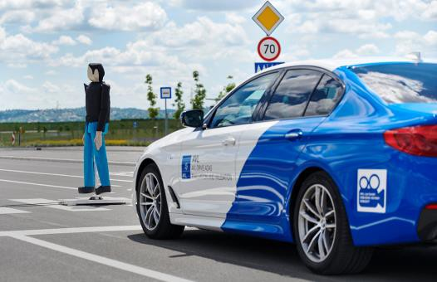
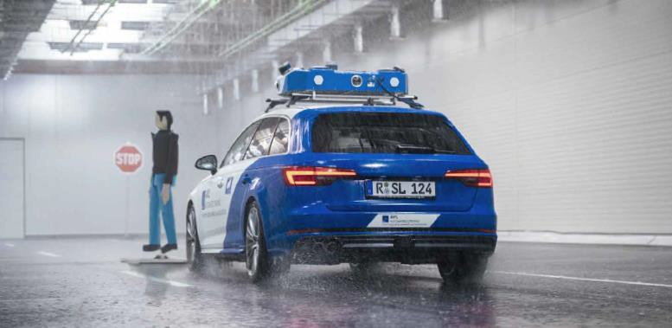
Abstract Submission SafeTrans Industrial Day, 09.11.2023 Adverse Weather Conditions in the Validation of ADAS/AD Sensors

Speaker  Company | Dr.-Ing. Armin Engstle  AVL SFR GmbH | Position  Country | Site Manager AVL Roding  Germany
E-Mail | armin.engstle@avl.com | Phone | +49 152-382-99520
Address Schorndorferstraße 91, 93426 Roding

Key topic assignment: Robust Sensor testing/validation; Validated digital twin; sensor measurement and simulation results in adverse weather conditions

The sensor technology of future automated driving functions and advanced driver assistance systems must work safely in all weather conditions. Currently, certification tests (e.g. Euro NCAP AEB VRU) are usually only performed in good weather conditions, but not in rain and fog, for example. In order to be able to test weather effects independently of real outdoor conditions, AVL has established an indoor sensor test center for the verification and validation of sensors for driver assistance systems.

The proposed conference contribution provides an overview on the following topics:
- The importance of systematic parameter variation for improving sensor perception also during adverse weather conditions.
- A realistic and reproduceable indoor ADAS / AD sensor testing facility for adverse weather conditions such as rain, fog and light.
- Relevant measurement results of lidar sensors in adverse weather conditions and resulting improvement approaches
- A digital twin of the sensor testing facility which provides a significant increase of parameter variation
.

Key Take-Aways:
- Considering sensor perception interferences due to adverse weather conditions is decisive for improving the quality of ADAS functions and indispensable for the road release of AD functions / vehicles.
- Even more than in the past the “right mix” of test and validation approaches is essential for a reliable and safe sensor and perception approval.
- An inverse test strategy from real-world data to indoor testing and virtual simulation is required to ensure a realistic cross validation of the different test and validation approaches (e.g. indoor vs. outdoor, static vs. dynamic SUT).

Brief Bio of the spokesman:

After starting his career at BMW in 2007, Armin joined AVL Software & Functions in 2011 being responsible for Vehicle and Hybrid Controls Software. From 2015 to 2018, he led the ADAS / AD Controls and Software Department at AVL before joining Zenuity from 2018 to 2020. Since June 2020, Armin is back at AVL, taking over the Product Management for DGT Perception Software and managing the newly founded AVL Sensor Lab in Roding/Bavaria.

